Website Blocker using Python:

1. There is a file in our computer known as the host file. If we add the redirect ip address and the host name in it, we can allow our browser to not connect to those websites.

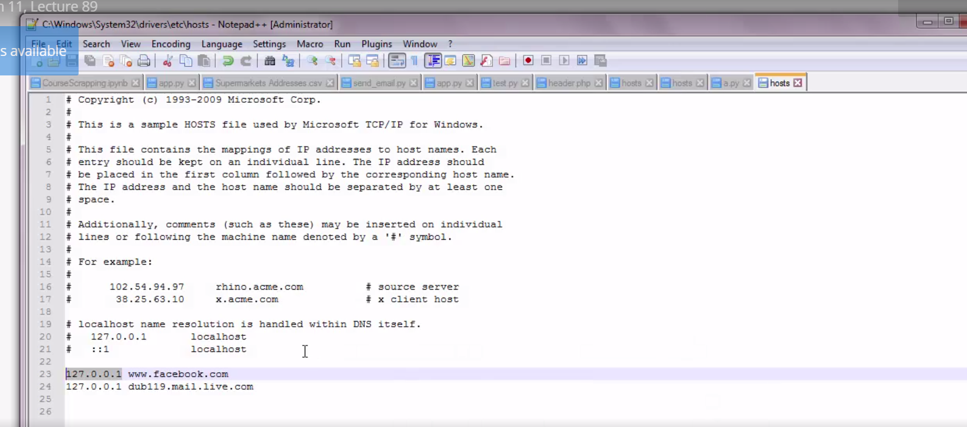

1. The host file on windows is located on this directory: as the image below.

The host file does not have an extension, but you can open it using a text editor. For Mac and Linux, it’s on /etc/hosts. You can open this file using file handling method and, edit it during certain times of the day and block those websites.

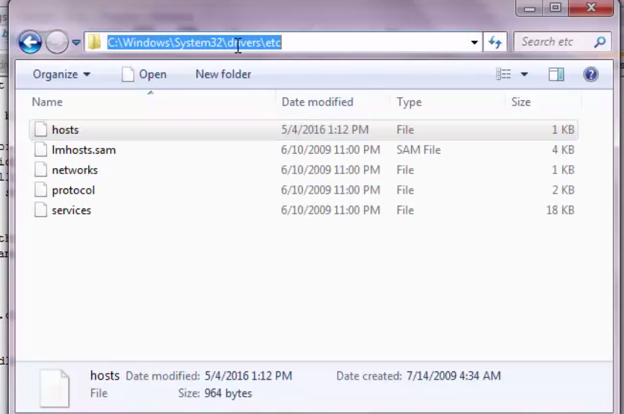

1. Sometimes the path: C:\Windows\System32\drivers\etc may be containing a special character like “C:\nWindows\System32\drivers\etc”. In that case python interprets the string as having a special character “\n”. To allow Python to interpret the path as a single string, use the following syntax:

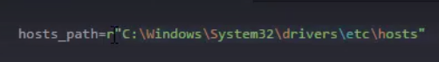

1. Python has a **datetime** class inside the **datetime** module. The [**datetime**](https://docs.python.org/2/library/datetime.html#module-datetime) module supplies classes for manipulating dates and times in both simple and complex ways. We will be using this module.





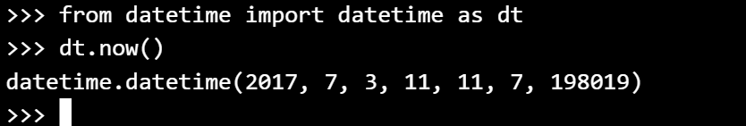  
  
 YEAR, MONTH, DAY, HOUR, MINUTE, SECOND, MILLISECOND

Thus, the value printed is an object of the class dt.

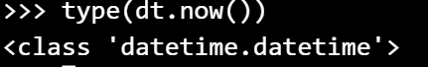

If we want to compare two date time objects like this: It gives an error because we are trying to compare an object with a tuple. So we need to convert a tuple to a dt object.

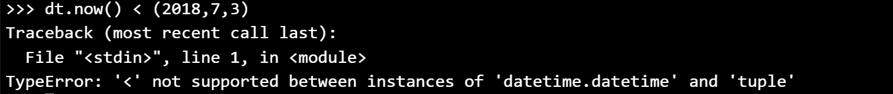

The way to do this is as follows:

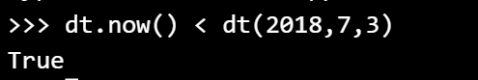

1. Now we must try to generate year, month, date, time in our program automatically. These are all integer values.

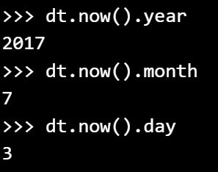

1. We want to block the websites between 8.00 AM till 4.00 PM. So ,we need to compare the hours only.  
     
   
2. The mode r+ is for reading and writing. So, we need to open “hosts” file and first check if at all it contains those websites we want to block. If the file contains then we pass, else we write to the file.
3. The readlines() reads the contents of the file into a list.

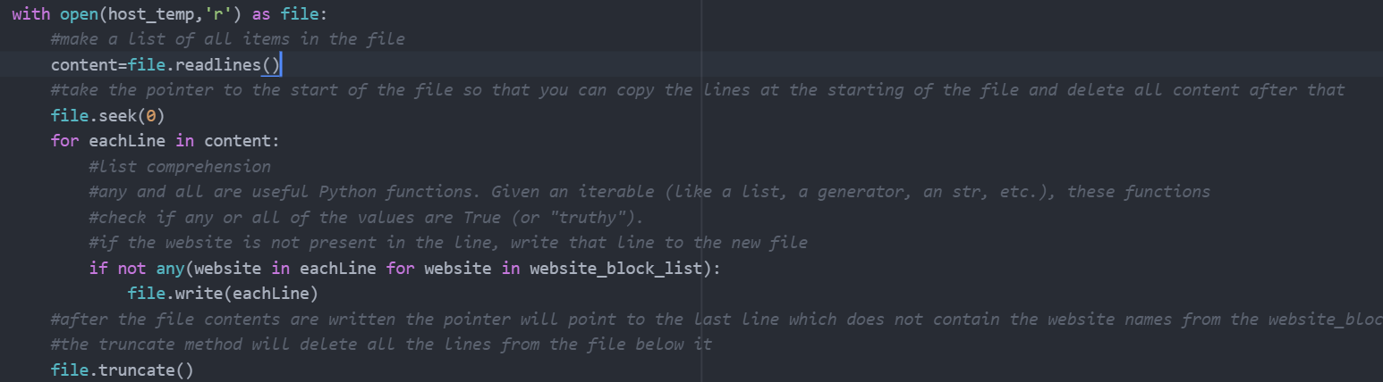

1. Now we want to write the contents of the file from the python script to the actual hosts file onto our system. If we try to do that, we get a permission error.

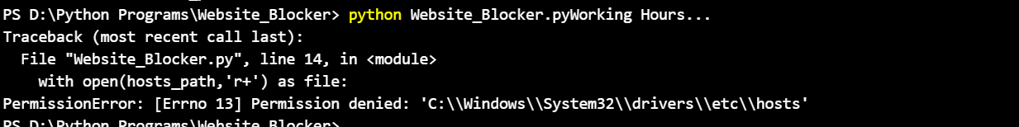

1. For mac/ linux run the code by sudo python Webiste_blocker.py. But this does not work with windows.
2. Go to cmd, open as administrator and move to the directory and run the python program.

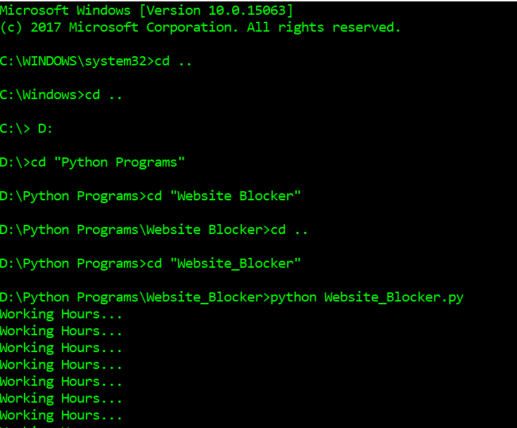

1. 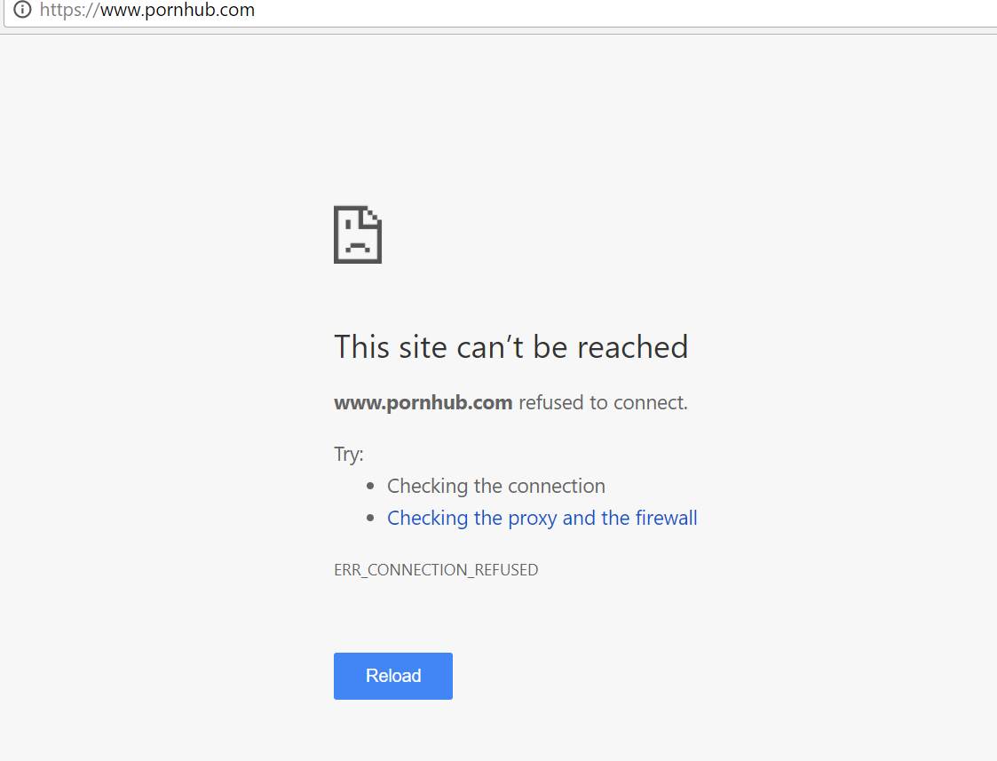

**RUN THE PROGRAM IN THE BACKGROUND**

1. We use the python.exe to normally run a python program. But to run the python in the background, you would want to use the python.exe file.
2. Change the extension to .pyw
3. Open the folder and double click on that file.
4. You should be able to see pyw running in your task manager
5. The hosts file is a protected file by windows, hence you may not be able to see any changes or that pyw.exe running in your task manager. So try testing it with host_temp.
6. To run the program as soon as the computer starts-🡪 Go to task scheduler

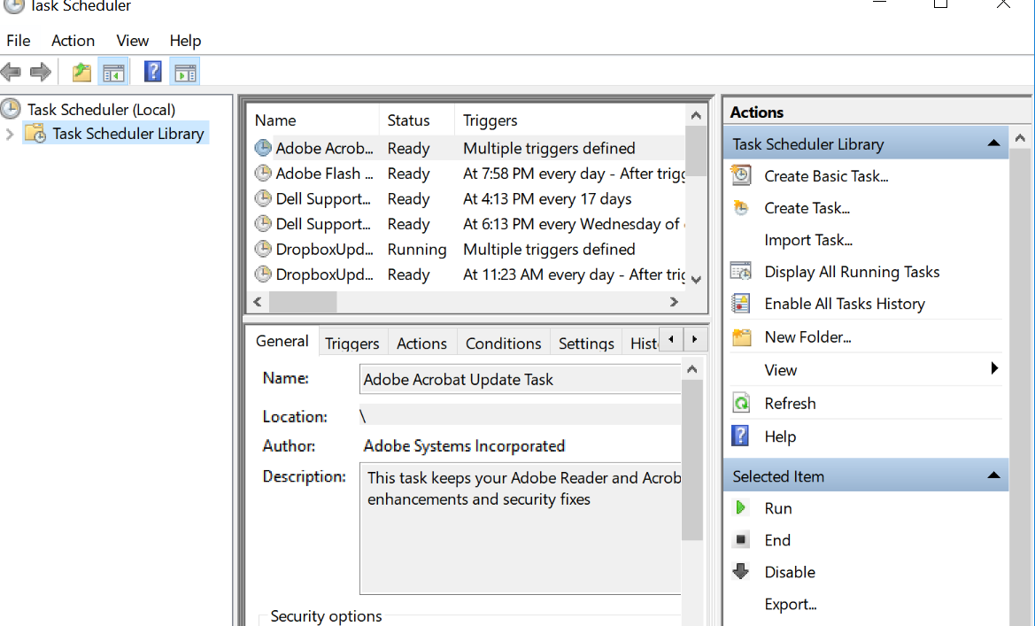

1. Then create a new task-🡪Put a name for that task-🡪

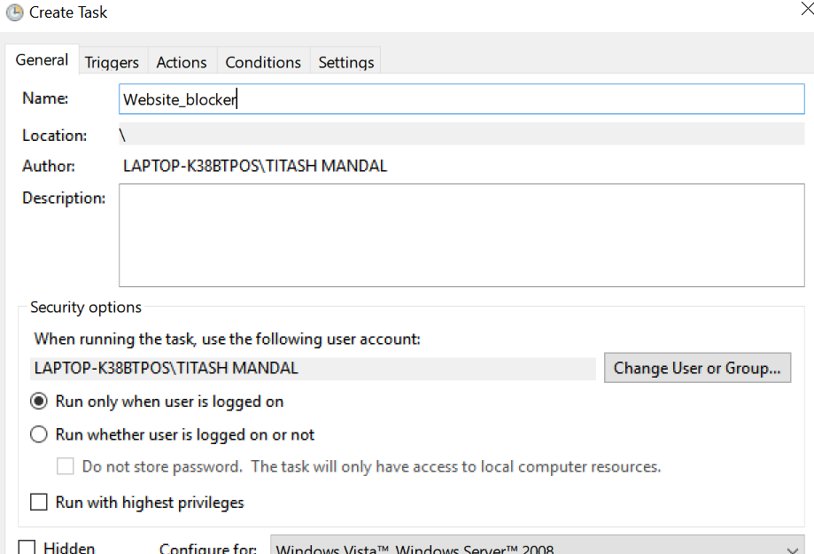

1. Then configure for Windows 10 (See at the bottom) and check run with highest priviledges – windows will or else run the script from a normal user too.

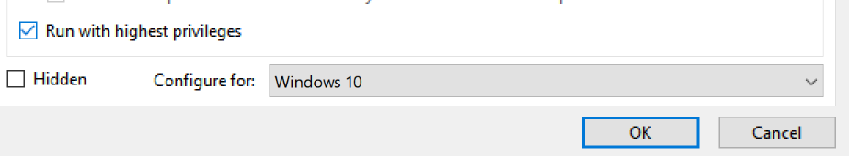

1. **Then go to triggers--🡪 new--🡪 at startup**

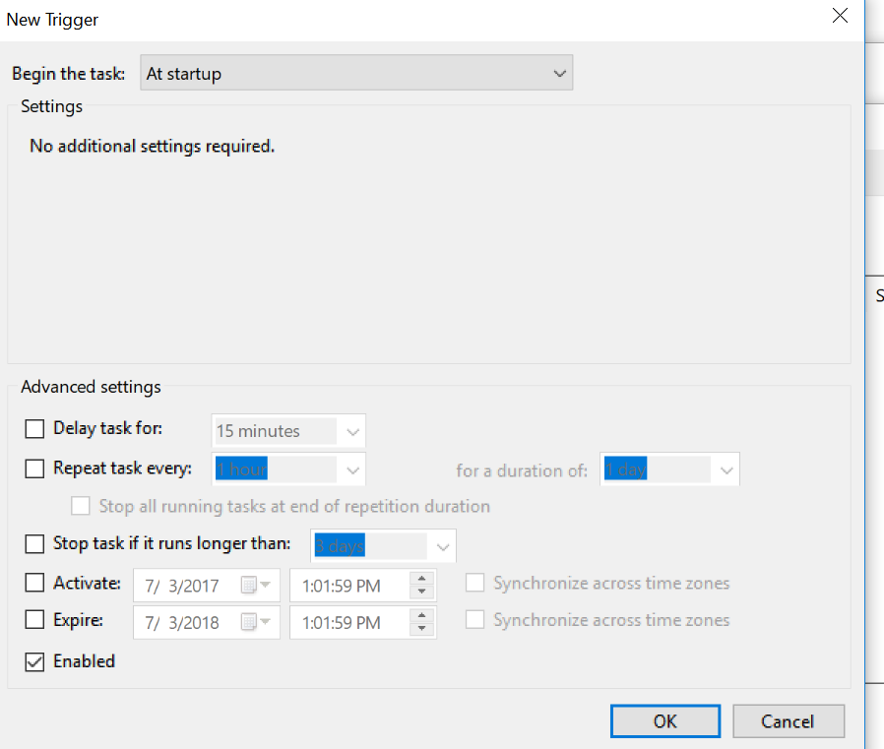

1. **Then go to action-🡪new---🡪start a program -🡪 browse to the website-blocker.pyw file.**

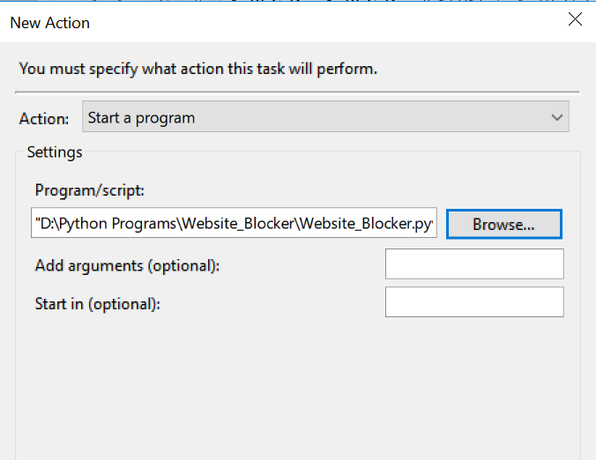

1. **Then go to Conditions Uncheck** the option that is like this:

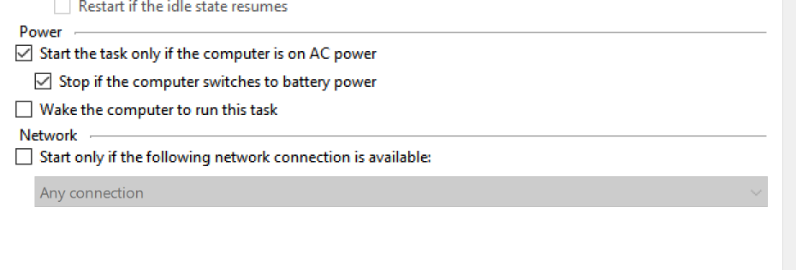

1. **Here is the website_blocker task**

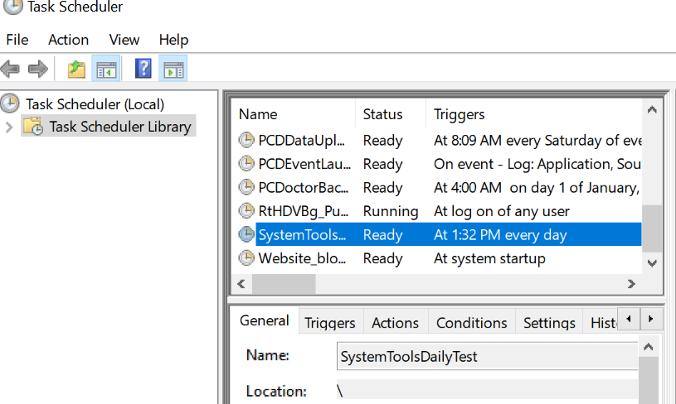

1. **Test the program by clicking run on the right side.**

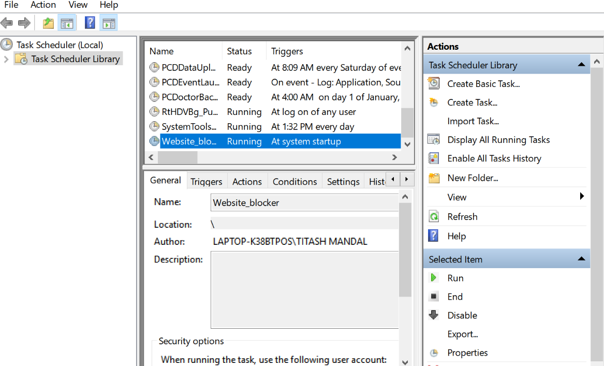

1. **Check in task manager.**